# Product Summary

* VDS= 60V,ID= 0.3A
* RDS(on)< 2.3Ω @VGS= 10V
* RDS(on)< 2.9Ω @VGS= 4.5V

# SOT-23

2

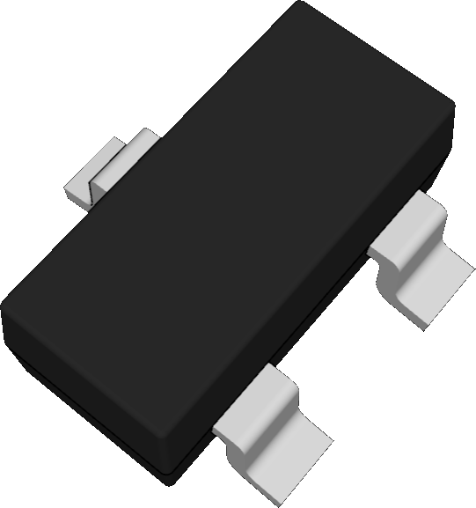

3

1

# Features

* ESD Protected(HBM) up to 2KV
* Advanced Trench Technology
* RoHS and Reach Compliant
* Halogen and Antimony Free
* Moisture Sensitivity Level 1

# Application

* Battery Operated Systems
* Direct Logic-level Interface:TTL/CMOS
* Solid-State Relays

# Marking Code

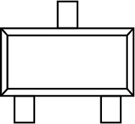

3

**K72**

1

2

**(Top View)**

|  |  |
| --- | --- |
| **Pin** | **Description** |
| 1 | Gate |
| 2 | Source |
| 3 | Drain |

# Schematic Diagram

3.Drain



1.Gate

2.Source

# Absolute Maximum Ratings

(Ta=25℃ unless otherwise specified)

|  |  |  |  |
| --- | --- | --- | --- |
| **Parameter** | **Symbol** | **Value** | **Unit** |
| Drain-Source Voltage | VDS | 60 | V |
| Gate-Source Voltage | VGS | ±20 | V |
| Drain Current-Continuous | ID | 0.3 | A |
| Maximum Power Dissipation | PD | 0.35 | W |
| Junction Temperature | TJ | 150 | °C |
| Storage Temperature Range | TSTG | -55 to +150 | °C |

# Thermal Characteristics

|  |  |  |  |
| --- | --- | --- | --- |
| Thermal Resistance,Junction-to-Ambient Note1 | RθJA | 357 | °C/W |

**Electrical Characteristics**

(Ta=25℃ unless otherwise specified)

|  |  |  |  |  |  |  |
| --- | --- | --- | --- | --- | --- | --- |
| **Parameter** | **Symbol** | **Test Condition** | **Min.** | **Typ.** | **Max.** | **Unit** |
| **Static Characteristics** | | | | | | |
| Drain-Source Breakdown Voltage | V(BR)DSS | VGS=0V,ID=250μA | 60 | -- | -- | V |
| Zero Gate Voltage Drain Current | IDSS | VDS=60V,VGS=0V | -- | -- | 1 | μA |
| Gate-Body Leakage Current | IGSS | VGS=±20V,VDS=0V | -- | -- | ±10 | μA |
| Gate Threshold Voltage Note2 | VGS(th) | VDS=VGS,ID=250μA | 1 | 1.5 | 2.5 | V |
| Drain-Source On-Resistance Note2 | RDS(on) | VGS=10V, ID=0.3A | -- | 1.8 | 2.3 | Ω |
| VGS=4.5V, ID=0.2A | -- | 2 | 2.9 | Ω |
| Forward Transconductance Note2 | gFS | VDS=5V,ID=0.2A | -- | 0.35 | -- | S |
| **Dynamic Characteristics** | | | | | | |
| Input Capacitance | Ciss | VDS=15V,VGS=0V,f=1MHz | -- | 31 | -- | pF |
| Output Capacitance | Coss | -- | 11 | -- | pF |
| Reverse Transfer Capacitance | Crss | -- | 6.5 | -- | pF |
| Total Gate Charge | Qg | VDS=10V,ID=0.3A, VGS=4.5V | -- | 1.7 | -- | nC |
| Gate-Source Charge | Qgs | -- | 0.3 | -- | nC |
| Gate-Drain Charge | Qgd | -- | 0.6 | -- | nC |
| **Switching Characteristics** | | | | | | |
| Turn-on Delay Time | td(on) | VDD=10V,ID=0.2A, VGS=10V,RGEN=10Ω | -- | 2 | -- | nS |
| Turn-on Rise Time | tr | -- | 15 | -- | nS |
| Turn-off Delay Time | td(off) | -- | 7 | -- | nS |
| Turn-off Fall Time | tf | -- | 20 | -- | nS |
| **Source-Drain Diode Characteristics** | | | | | | |
| Diode Forward Voltage Note2 | VSD | VGS=0V,IS=0.3A | -- | -- | 1.2 | V |
| Diode Forward Current Note1 | IS |  | -- | -- | 0.3 | A |

Note: 1. Surface Mounted on FR4 Board, t ≤ 10 sec.

2. Pulse Test: Pulse width≤300μs, duty cycle≤2%.

# Typical Characteristic Curves

1 1

VGS=10V

VGS=5V

VGS=4V

VGS=3V

VGS=2V

TJ=25℃

TJ=125℃

TJ=-55℃

0.8 0.8

Drain Current (A)

Drain Current (A)

0.6 0.6

0.4 0.4

0.2 0.2

ID

ID

0

0 1 2

3 4 5

0

0 1 2

3 4 5 6 7

VDS Drain-Source Voltage (V) VGS Gate-Source Voltage (V)

3

2.5

RDS(on) On-Resistance (mΩ)

2

1.5

100

10

TJ=-55℃

TJ=25℃

TJ=125℃

IS Source Current (A)

1

1

0.5

0.1

0

VGS=4.5V

VGS=10V

0 0.2

0.4 0.6

0.8

0.01

0.0

0.2

0.4

0.6 0.8

1.0

1.2

ID Drain Current (A) VSD Source-Drain Voltage (V)

5 103

VGS=0V,f=1MHz

Crss

Coss

Ciss

VDS=10V ID=0.3A

VGS Gate-Source Voltage (V)

4

C Capacitance (pF)

102

3

2

1

0

0 0.5 1

1.5 2

101

100

0

10 20 30 40

Qg Gate Charge (nC) VDS Drain-Source Voltage (V)

1.20

Normalized Breakdown Voltage

1.15

1.10

V(BR)DSS RDS(on)

2.5

VGS=10V ID=0.3A

ID=250μA

Normalized On-Resistance

2.0

1.05 1.5

1.00

0.95

1.0

0.90

-100

-50 0 50 100 150 200

TJ Junction Temperature (℃)

0.5

-100

-50 0 50 100 150 200

TJ Junction Temperature (℃)

# Package Outline

SOT-23

Dimensions in mm

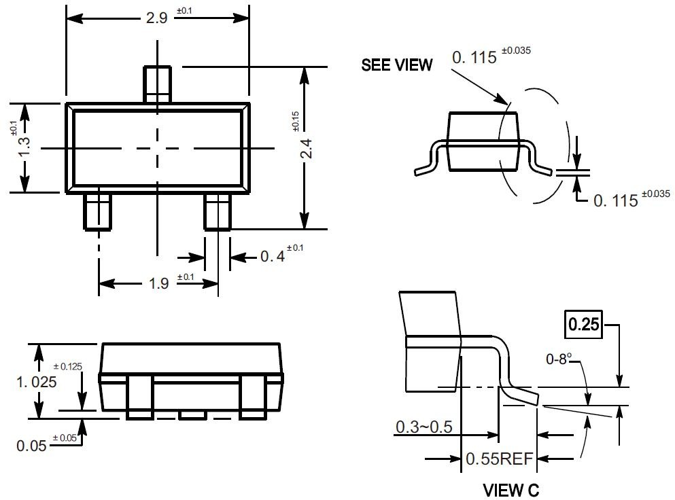

# Ordering Information

|  |  |  |
| --- | --- | --- |
| Device | Package | Shipping |
| TN7002KNSA | SOT-23 | 3,000PCS/Reel&7inches |

**Conditions of Soldering and Storage**

## Recommended condition of reflow soldering

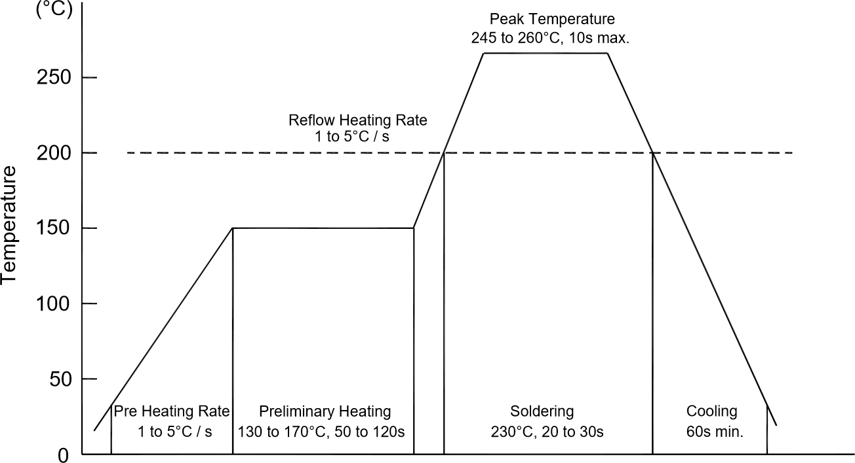

Recommended peak temperature is over 245°C. If peak temperature is below 245°C, you may adjust the following parameters:

* + Time length of peak temperature (longer)
  + Time length of soldering (longer)
  + Thickness of solder paste (thicker)

## Conditions of hand soldering

* + Temperature: 300°C
  + Time: 3s max.
  + Times: one time

## Storage conditions

### Temperature

5 to 40°C

### Humidity

30 to 80% RH

### Recommended period

One year after manufacturing

# Package Specifications

* The method of packaging

SOT-23

3,000 pcs per reel

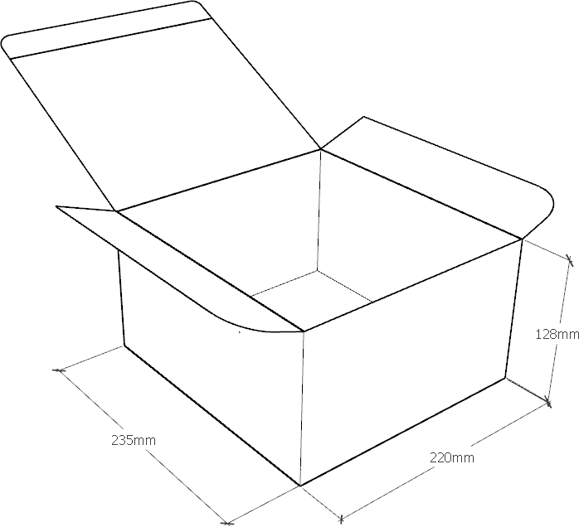30,000 pcs per box 10 reels per box

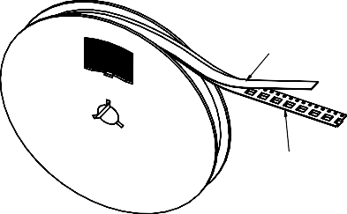

Cover Tape

Carrier Tape

## Embossed tape and reel data

D



T1

T2

E

F

120,000 pcs per carton 4 boxes per carton



A

B

C

|  |  |
| --- | --- |
| Symbol | Value (unit: mm) |
| A | Ø 177.8±1 |
| B | 2.7±0.2 |
| C | Ø 13.5±0.2 |
| E | Ø 54.5±0.2 |
| F | 12.3±0.3 |
| D | 9.6+2/-0.3 |
| T1 | 1.0±0.2 |
| T2 | 1.2±0.2 |

**Reel (7'')**

